1. Starting from **Grant Details** (Grant Management>All Grants>Click on applicable Grant Name)
2. A screenshot of a computer

   Description automatically generatedClick on Post-Award>Management>Amendments
3. Click on the plus icon in the upper right-hand corner



1. Enter Amendment Request Name and check Budget under Areas to Amend

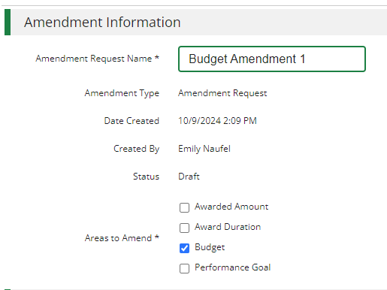

1. Click Download Budget
2. Open the excel file (if using Chrome will display in the upper right-hand corner of your browser to open)

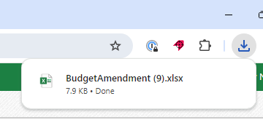

1. Adjust the excel file leveraging the bulleted instructions below



* To ***add a line item*** include a Category, Line Item name, Line Item Type and Total Budgeted (Direct Cost) at a minimum (include match or other more granular budget details as required)
* To ***remove a line item*** delete the line item from the file
* To ***change total budgeted*** for a line item update the Total Budgeted (Direct Cost)
* To ***add, remove of change match*** update the Match Value columns

**Important File Reminders:**

* Do not change the column headers text
* Do not delete the columns identified with a *
* Actuals columns are for reference only and changing in the spreadsheet will not result in any changes in AmpliFund
* Grant Budgeted column is for reference only and changing in the spreadsheet will not result in any changes in AmpliFund

1. Save the File

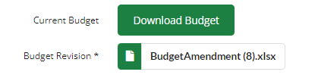

1. Upload saved version of the file

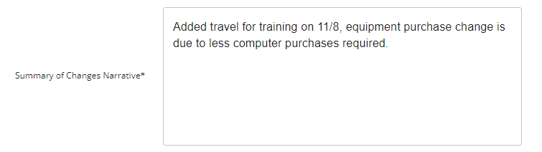

1. Add Summary of Changes Narrative
2. Review the Summary of Proposed Changes

*If you need to make further edits, go back to the saved excel file, adjust as needed and re-upload excel file to the amendment.*

1. Add Justification or Upload File(s) as/if required by your Funder
2. Click Save to return and finish later or Submit to submit your finalized amendment to your funderA green sign with white text

   Description automatically generated