YOUR LOGO HERE 
[Organization Name] & AmpliFund Partnership
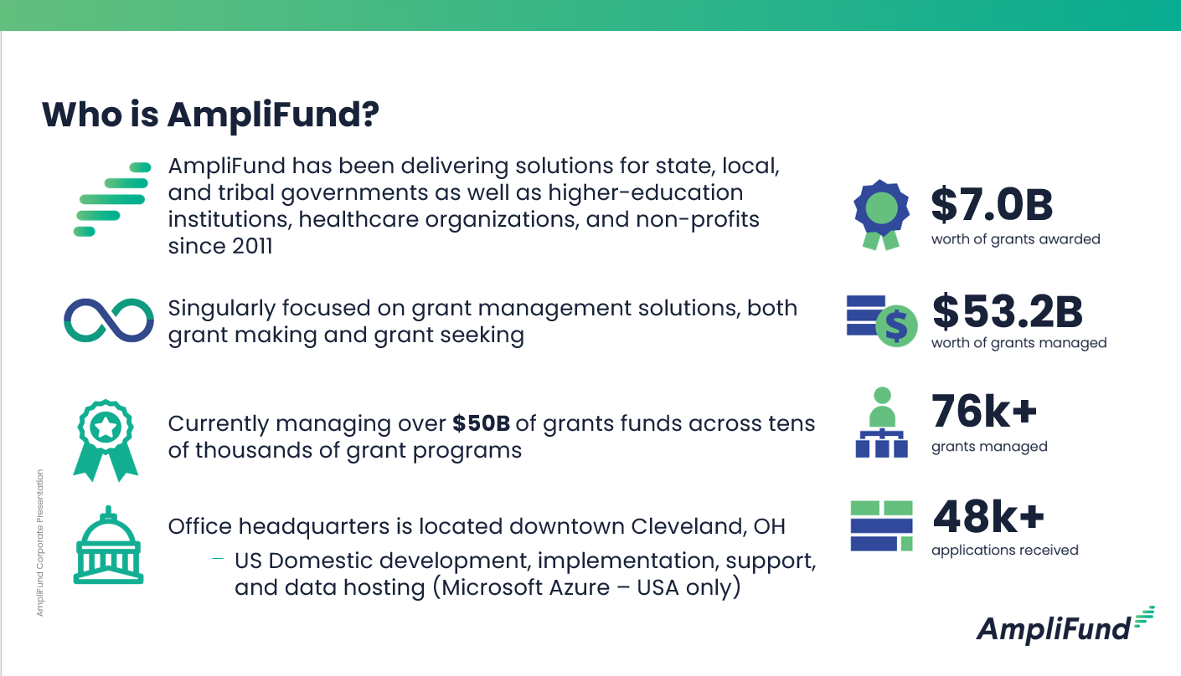

[Organization Name] Selected AmpliFund to solve these challenges:
1.
2.
3.

[Organization Name] Internal Key Contacts for Partnership:
Executive Sponsor: Name, Title
Project Manager: Name, Title

Upcoming Key Milestones and/or Trainings:
Key Milestone: Topic / Date
Training: Topic / Date

