Awarding Business Process Documentation: [Customer Name]
Last Updated [Date]
Section 1: Fund Creation
A fund is the income source for an award, allowing reporting and tracking of awards obligated and liquidated.

Business Process Owner: [Name]
Important Note: Income Received must be greater than or equal amount awarding

- Internal naming convention: [add here]
- Custom Fields required to be completed: [if applicable add here]

Section 2: Opportunity Funding Set-up (if awarding via opportunity)
An opportunity allows organizations to receive applications and is linked to both he fund and resulting awards.

Business Process Owner: [Name]
- Funding Linked to Opportunity
- Award Management>Fund Opportunities
- Opportunity details page>Funding Information Section

Important Note: Fund must be linked to opportunity prior to creating awards

Section 3: Workflow Set-up
A workflow is required to create awards from an application.
[Add details here about your application review workflow configuration and the awarding step]
Business Process Owner: [Name]
Section 4: Award Set-Up & Configuration
An award creates the basis for recipient reporting and interaction with the funder in AmpliFund.
Business Process Owner: [Name]
Step 1: Award Creation:
- Awards are Created by: Workflow Action by [Name]
- Award creation triggers a notification to the applicant that their application has been approved.
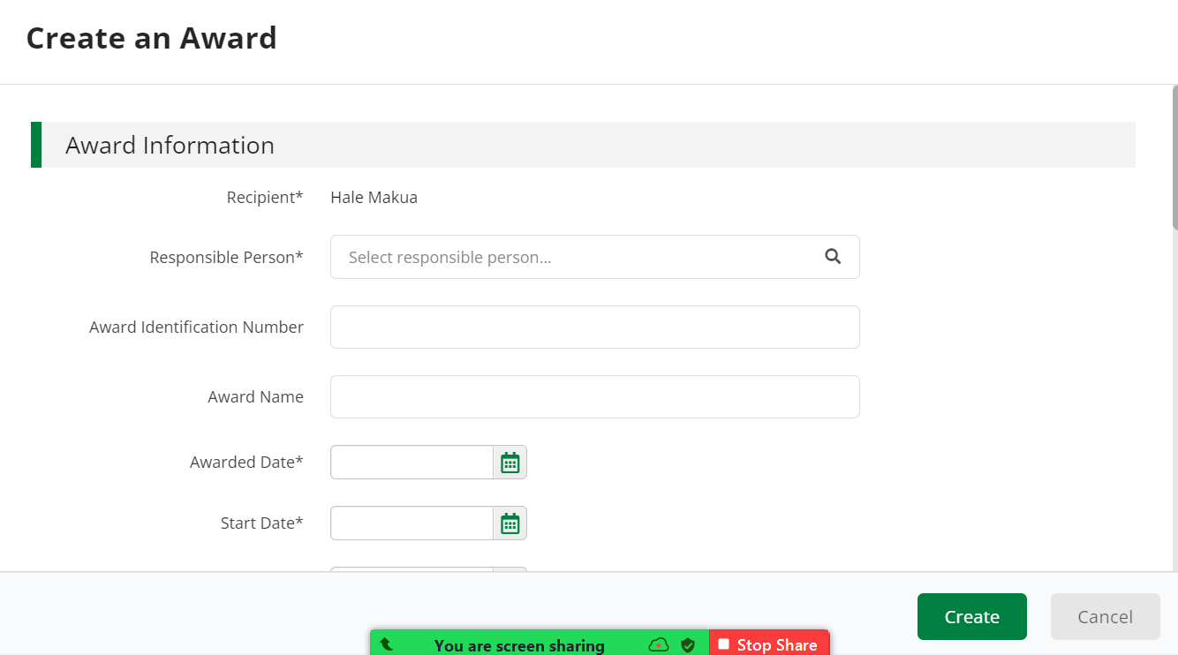
Award Funding:
- Awards are Funded by: Fund
- Funding Source is: [Multiple Funds or One Fund]

Step 2: Configure Award Details Page (Award Management>Awards):
- Configured by: [Name]
- Fields in use and internal name
  - [Example] Award Identification Number=
  - [Example] Payment Account Number=
- Custom Fields to complete: [Add here if applicable]
Step 3 (if applicable): Running Grant Agreement/Contract (Reports>Custom Reports>REPORT NAME)
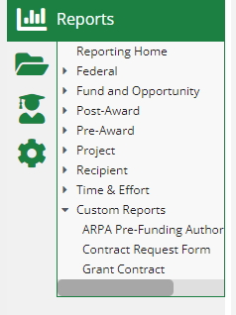
- Fields that must be completed for full agreement/contract to populate: [add here if applicable]
Step 4: Award Settings (Award>Post Award>Settings>Grant Settings):
Award settings allow the ability for use of reporting periods and trigger tasks for recipients to receive reminders of reporting requirements.
- Configured by: [Name]
- Budget Reporting Period Cadence: [Monthly, Quarterly, Bi-Annually, Annually]
- Budget Reporting Period Due Date: # Days
- Performance Reporting Period Cadence: Monthly, Quarterly, Bi-Annually, Annually]
- Performance Reporting Period Due Date: # Days
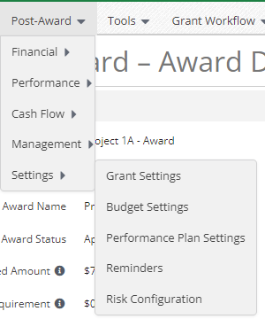

Example:
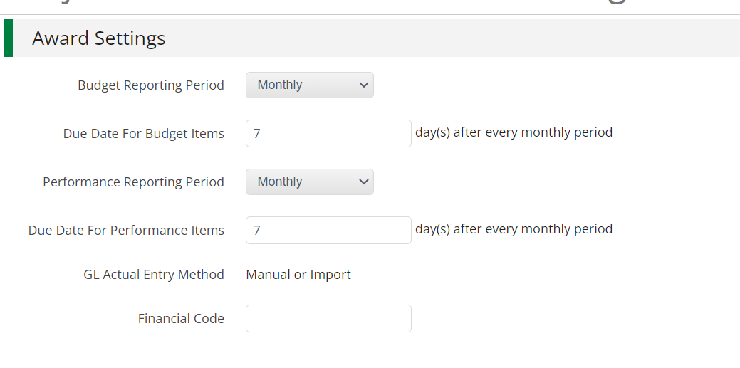
Step 5: Budget Permissions (Award>Post Award>Settings>Budget Settings):
Budget permissions identify who has access to edit the budget and enter expenses.
- Configured by: [Name]
- Budget Creation Permissions: [Recipient can View, Funder can Edit OR Recipient and Funder can edit OR Recipient can Edit Funder can View]
- Expense Creation Permissions: [Recipient can View, Funder can Edit OR Recipient and Funder can edit OR Recipient can Edit Funder can View]
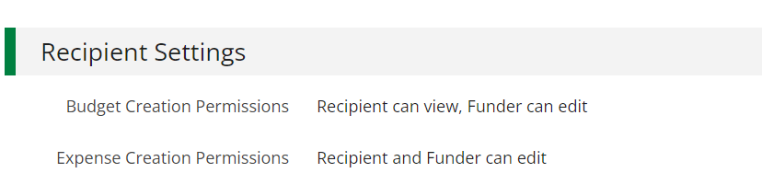
Step 6: Performance Plan Permissions (Award>Post Award>Settings>Performance Plan Settings):
Performance plan permissions identify who has access to edit the plan and enter achievements.
- Configured by: [Name]
- Performance Plan Creation Permissions: [Recipient can View, Funder can Edit OR Recipient and Funder can edit OR Recipient can Edit Funder can View]
- Achievement Creation Permissions: [Recipient can View, Funder can Edit OR Recipient and Funder can edit OR Recipient can Edit Funder can View]
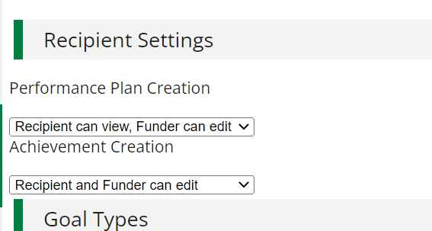

Step 7: Budget Configuration (Award>Pre-Award>Submission Budget)
- Budget is created by: Copying from Pre-Award by: [Name]
- Note: Once copied a budget can be edited via Post-Award>Financial>Budget
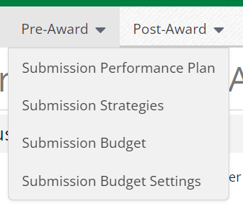
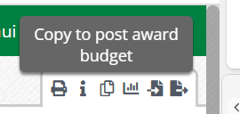
Step 8: Performance Plan (Award>Pre-Award>Submission Performance Plan)
- Performance Plan is created by: Copying from Pre-Award by [Name]
- Note: Once copied a performance plan can be edited via Post-Award>Performance>Performance Plan
Step 9: Activate Award
- Completed by: [Name]
- Sends an email to the recipient to log-in to AmpliFund and begin managing their award

